Character

In game terms, a character is simply a collection of statistics and other information that help define and accurately represent a being in the Elder Scrolls setting. This same system is also used to define the various people, monsters, and other beings that populate the setting. From this point forward, the player characters will be referred to as PCs, while non-player characters will be referred to as NPCs. Even monsters and other creatures are classified as characters. Characters, particularly PCs, can be divided into two main parts: the character concept and the character profile.

***Character Concept***

A character concept simply defines who the character is within the context of the game setting. This can range from a simple idea in a player’s head (a dashing rogue who fights with a rapier!) to an in depth back-story written before the game begins. However extensive it may be, all characters should have a basic concept associated with them, even the NPCs that the GM creates for the party to interact with.

***Character Profile***

A character profile defines who the character is within the context of the game rules, providing a suite of stats which can be used to resolve a variety of dramatic scenarios in which the character may find themselves. These values are the focus of the majority of the rules in this book, and will be the focus of the rest of this section as well.

Each character profile is made up of the following elements:

* ***Attributes***: Eight values that represent the broad physical and mental capabilities of the character.
* ***Characteristics***: Derived statistics that represent more specific measurements of a character's capabilities and their current resources.
* ***Skills***: A set of categories and associated ranks that reflect a character’s ability to perform certain actions.
* ***Talents***: A set of unique abilities the character has come to possess through training or experience.
* ***Traits***: Rules that reflect inherent physical facts about the character, certain abilities they naturally possess, or particular features of their personality.
* ***Magic***: The set of all magical abilities the character possesses

***Attributes***

The eight Attributes are values that define the broad physical and mental capabilities of each character. Attributes have two pieces of information associated with them: the attribute score, and the attribute bonus. A given attribute’s Score is a value, at minimum zero with no ceiling, that represents that attribute. The scores tend to hover in the 45-55 range on average. Higher values are better. A given attribute’s Bonus is a value equal to the tens digit of the associated attribute score, and is used for certain calculations where the full score is too large.

Below is a list of all the attributes that define a character, how they are abbreviated, and what they each represent. All attributes have a hard set max at 70. Only magical fortification can bring an Attribute score beyond this max.

***Strength*** (Str / StrB) measures a character’s physical prowess, and their ability to employ that prowess and push themselves to their physical limits.

***Endurance*** (End / EndB) measures a character’s physical health, stamina and toughness, and their resistance to damage.

***Agility*** (Ag / AgiB) measures a character’s physical speed, reflexes, and coordination, reflecting their overall ability to move quickly and gracefully.

***Intelligence*** (Int / IntB) measures a character’s mental prowess, problem solving, reasoning, ability to recall information, and understanding of the mysteries of magicka.

***Willpower*** (Wp / WpB) measures a character’s mental control, resilience, and their ability to control and shape magicka.

***Perception*** (Prc / PcB) measures a character’s physical awareness, as well as the accuracy of their “gut instincts” and intuition.

***Personality*** (Prs / PsB) measures a character’s natural charisma, presence, expressiveness, and social abilities.

***Luck*** (Lck / LkB) measures a character’s good fortune: how often events tend to go their way. A character’s Luck cannot exceed 50.

***Characteristics***

A character’s characteristics are statistics derived from a character’s attributes that represent more specific measurements of a character’s capabilities. While attributes reflect general aptitude in a certain area, characteristics measure specific values with very precise meanings used for particular game mechanics.

***Passive Awareness (½ 10’s place of their Awareness TN)***

A character may wish to sneak past an unalert sentry or the GM may wish to keep a Secret Door actually a secret. In both of these cases, Passive Awareness can be deployed.

Unless a character is actively searching or monitoring their surroundings, characters will roll their Sneak skill against the target's Passive Awareness. PA is a required DoS needed to move past the sentry undetected.

Secret Doors and other hidden components of the environment can be discovered using Passive Awareness. When designing a location with such a component, the GM should assign a PA value to the hidden component. If the character passes within a certain distance of the secret and their PA is equal to or greater than the assigned value, then they become aware of something. The GM may have them become aware of a trail in the dust, hinting towards a secret door (however, they may still need to find out how to open it) or they notice that a brick has been obviously moved or tampered with. Just because they are made aware, that does not mean they immediately know what it is or how to access it.

Passive Awareness is equal to Half (Rounded using the Ones Place value) the tens place value of the character’s Awareness skill.

***Health Points (Endurance)***

A character’s Health Points (HP) maximum is equal to their Endurance score and reflects how much damage they can withstand before they die. Damage that characters take reduces their current HP by the equivalent amount. For information, see Physical Health in Chapter (COMBAT).

***Stamina Points (EndB + ½ WpB)***

A character’s Stamina Point (SP) maximum is equal to their Endurance bonus plus half their Willpower bonus, though it may be modified in other ways. When characters reach zero SP they gain a level of the fatigue condition. For information, see Conditions in Chapter (COMBAT).

***Magicka Points (Intelligence)***

A character’s Magicka Points (MP) maximum, which is equal to their Intelligence score, is a measure of how much magical energy (known as magicka) the character is naturally able to draw upon from their reserves. For information, see Chapter (MAGIC).

***Initiative Rating (AgiB + IntB + PcB)***

A character’s Initiative Rating (IR) is used when making initiative rolls, and is equal to the sum of their Agility, Intelligence, and Perception bonuses. For information on initiative, see Combat in Chapter (COMBAT).

***Size Category (Standard by default)***

A character’s Size Category reflects their physical size, and the effects thereof. All roughly human sized characters are Standard size, but some characters can be larger or smaller. For information see Movement & Size in Chapter (COMBAT)

***Speed (AgiB + ½ StrB)***

A character’s Speed, equal to the sum of their Agility bonus and half their Strength bonus, is how many meters a character can move every time they take the “Move” action. For information, see Movement & Size in Chapter (COMBAT).

***Carry Rating (2 x StrB)***

A character’s Carry Rating (CR), equal to the sum of their Endurance bonus and twice their Strength bonus, provides a measure of how much weight they can carry, lift, or push. For information, see Items & Encumbrance at the end of this chapter.

***Lucky/Unlucky Numbers***

A character has a number of Lucky Numbers equal to their Luck bonus, and a number of Unlucky numbers equal to five minus their Luck bonus. These numbers determine when they critically succeed or critically fail, and are determined at character creation. If a character’s Luck bonus drops by one or more, then change one or more of their existing Lucky numbers (player’s choice as to which ones) into Unlucky numbers so that their total number of Lucky/Unlucky numbers remains the same. See Critical Successes & Failures for details.

***Attunement (½ WpB)***

Attunement represents a character’s ability to bond with magical items and is equal to Half their Willpower Bonus, rounded up). See Enchanting in Chapter (CRAFTING) for details

***Experience Points***

The character’s current amount of Experience Points (XP), which increase throughout a campaign. These can be spent on advancements. See Character Advancement later on in this chapter.

***Starting Languages***

All characters begin play with Cyrodilic and their Cultural Language at ***Fluency (2)***. All characters have an amount of points equal to their ***IntB*** that they can spend on learning additional languages or attaining Fluency in one of their default languages.

***Luck***

Luck is unique amongst the other attributes in that it represents something more abstract than a character’s physical strength or mental resilience. Luck reflects the tendency of events to work out in a character’s favor. This can seem to represent nothing more than coincidence or good fortune, but destiny and fate play a role as well.

Because Luck governs no skills, a character will not be called upon to test it as often as they might for another attribute. Luck is used in several ways: it determines a character's chance of critical success or failure through their Lucky and Unlucky numbers, they can spend Luck points for certain benefits, they can attempt Luck tests in certain circumstances, and they can burn Luck permanently in exchange for a number of powerful effects.

***Luck Tests***

In certain situations the GM can call upon the character to make a Luck test in scenarios when they need to determine whether or not some random event happens to work in the character’s favor. For example, if a character is knocking on doors during the night trying to find someone to help them, the GM could have the character make a Luck roll to determine if someone happens to be awake to hear them. These tests function just like any other attribute test.

***Burning Luck***

The player characters are the heroes of the story, and fortune favors heroes! Characters may choose to permanently reduce their Luck attribute score in order to benefit from a number of different effects. This is known as Burning Luck.

Luck that a character burns never regenerates naturally, However they can buy back Burned Luck as they would any other Attribute. A character may burn any amount of Luck at any time.

Characters may burn Luck for the following effects. If they do not have the required amount, simply burn all remaining Luck:

***Burn 1 Luck***: Add a degree of success to a successful test. This can be done multiple times for a given test.

***Burn 3 Luck***: Re-roll a failed test. This may only be done once for a given test.

***Burn 5 Luck***: Negate the effects of a critical failure. This must be done immediately after the test is rolled.

***Burn 10 Luck***: Turn a failed Death Save into a successful one.

# Character Creation

Legendary heroes fill the history of the Elder Scrolls setting, but even the greatest heroes need to start somewhere. The world of Tamriel is a vast and diverse one, and there are an enormous number of potential characters a player may want to create. However there are some things that all characters have in common, and it is on this common ground that we can start to build up a new character.

Standard character creation is a ***six*** step process. It is necessary to go through these steps in the correct order, and it is recommended you read through this list before moving on in order to inform your future decisions. When you actually start building the character, write down the details from each step on a character sheet as you go along so you don’t lose track of things.

***Step 1***: **Select a Race**

During this step you will choose your character’s race. We have included the “core” races featured in the games in this book, though additional races can be found in the ***Player's Handbook***. You should ask your GM which era the game is taking place in, and which races are allowed for the campaign, before you pick one. Each race comes with their own attribute baseline used to generate attributes for members of that race, and many races have bonus powers & traits.

***Step 2***: **Generate Attributes**

During this step you will get to generate your attribute scores using dice and the attribute baseline appropriate to your choice of race in the previous step.

***Step 3***: **Determine Birthsign**

Next, you determine your character’s Birthsign, choosing the charge of the warrior, mage, or thief and then rolling on the appropriate table. There is a chance during this step that the character will receive the Star-Cursed version of a sign instead, reflecting the threatening presence of the Serpent sign at the time of their birth.

***Step 4***: **Choose a Culture**

Next, you may select your character’s Culture, one of three Cultural Traits, and distribute your “Cultural Skill” budget. This culture represents where and how your character was raised and the influences that affected you growing up. You may form any race and culture combination that you can explain away with a backstory.

***Step 5***: **Spend CrP & Purchase Equipment**

Next, you spend your allotted CrP on any advancements that you desire. Any CrP remaining after this process is over is converted to XP. Characters also start with a budget of drakes which can be used in this step to purchase equipment and other items that the character will begin the game with.

***Step 6***: **Finishing Touches**

Finally, calculate your character’s characteristics and finalize any remaining aspects of the character sheet. You’re good to go!

***Campaign Start***

Before the Players can create their characters, the GM must choose the Campaigns ***Starting Power*** and its ***Progression Rate***. Progression Rates are detailed in the ***Character Progression*** section below.

***Starting Power***

The campaign’s starting power details the characters starting CrP and Cultural Skills.

| ***Level*** | ***CrP*** | ***Talent Lvl*** | ***Wealth*** | ***Cultural*** | ***Attribute Die*** | ***Trait Max*** |
| --- | --- | --- | --- | --- | --- | --- |
| Low | 30 | 1 | 250 | 20 | 1d10 | +10 |
| Default | 40 | 2 | 500 | 30 | 2d10 | +15 |
| High | 50 | 3 | 1000 | 40 | 3d10 | +20 |

***Generating Attributes***

During this step you will roll for your Attribute scores, using the Attribute baseline appropriate to your choice of race.

Roll ***Xd10*** seven times and once this is complete assign each of the resulting values to one of your attributes (except Luck). Add each roll to the attribute score of the assigned attribute that is listed in your attribute baseline. The amount of D10’s you roll for your attributes is listed on the ***Campaign Starting Power*** chosen by the GM under ***Attribute Die.***

When rolling for Luck, you roll XD10 and add 30 to the resulting value.

***Generate Lucky Numbers***

Before finishing off the character, it is time to decide which numbers are tied to your fate! Each character has a set of Lucky and Unlucky numbers that, when rolled as a test result, result in a critical success or critical failure (respectively). To generate your Lucky and Unlucky numbers, follow these steps:

* A character has a number of Lucky Numbers equal to their Luck bonus. Roll 1d100 this many times, rerolling any duplicates. These are your Lucky Numbers!
* A character has a number of Unlucky Numbers equal to five minus their Luck bonus. Roll 1d100 this many times, rerolling any duplicates (and rerolling any of your Lucky Numbers). These are your Unlucky Numbers!

If a character’s Luck bonus changes later, then convert Lucky and Unlucky numbers as appropriate.

***Races***

The races provided in this book encompass the core races portrayed in the Elder Scrolls games. Additional races can be found in the ***Advanced Player's Guide***. Each race comes with their own

Attribute baseline used to generate attributes for members of that race, and many races have bonus powers or traits. You should ask your GM which races are allowed in the campaign before you pick one.

***Altmer***

*The High Elves consider themselves the most civilized culture of Tamriel; the common tongue of the Empire, Tamrielic, is based on Altmer speech and writing, and most of the Empire's arts, crafts, and sciences derive from High Elven traditions. Deft, intelligent, and strong-willed, High Elves are often gifted in the arcane arts, and High Elves boast that their sublime physical natures make them far more resistant to disease than the "lesser races."*

**Baseline Attributes**

| ***STR*** | ***END*** | ***AG*** | ***INT*** | ***WP*** | ***PRC*** | ***PRS*** |
| --- | --- | --- | --- | --- | --- | --- |
| 30 | 33 | 33 | 44 | 40 | 35 | 35 |

**Native Tongue:** *Altmeris*

**Traits**

* ***Highborn***

Altmer have a +20 to their Max Magicka and naturally regain lost magicka at twice the normal rate.

* ***Resist Disease (2)***

The character gains a +20 on Endurance tests made to resist contracting disease or having a disease worsen.

* ***Weakness (Magic, 3)***

The character takes 3 extra damage from sources of harmful spells and takes a -30 on Willpower tests made to resist non-damaging spells.

* ***Mental Strength***

Altmer ignore all penalties to Willpower tests made to resist magic.

***Argonian, Saxhleel***

*At home in water and on land, the Argonians of Black Marsh are well-suited to the treacherous swamps of their homeland, with natural immunities protecting them from disease and poison. The female life-phase is highly intelligent, and gifted in the magical arts. The more aggressive male phase has the traits of the hunter: stealth, speed, and agility. Argonians are reserved with strangers, yet fiercely loyal to those they accept as friends.*

**Baseline Attributes**

| ***STR*** | ***END*** | ***AG*** | ***INT*** | ***WP*** | ***PRC*** | ***PRS*** |
| --- | --- | --- | --- | --- | --- | --- |
| 36 | 35 | 39 | 37 | 35 | 36 | 32 |

**Native Tongue:** *Jel*

**Traits**

* ***Amphibious***

Argonians can breathe water and ignore all penalties to combat rolls due to swimming. Additionally, their swim speed is doubled.

* ***Resist Disease (5)***

The character gains a +50 on Endurance tests made to resist contracting disease or having a disease worsen.

* ***Immunity (Poison)***

The character is immune to Poison Damage.

* ***Reptilian Metabolism***

The Argonian doubles the duration of all effects from consumables, such as Food, Drink, and Potions. If the consumable lacks a duration, increase the numerical effect by 2.

***Bosmer***

*The Wood Elves are the various barbarian Elven clanfolk of the Western Valenwood forests. These country cousins of the High Elves and Dark Elves are nimble and quick in body and wit, and because of their curious natures and natural agility, Wood Elves are especially suitable as scouts, agents, and thieves. But most of all, the Wood Elves are known for their skills with bows; there are no finer archers in all of Tamriel.*

**Baseline Attributes**

| ***STR*** | ***END*** | ***AG*** | ***INT*** | ***WP*** | ***PRC*** | ***PRS*** |
| --- | --- | --- | --- | --- | --- | --- |
| 31 | 31 | 41 | 35 | 33 | 44 | 35 |

**Native Tongue:** *Bosmeris*

**Traits**

* ***Beast Tongue***

Bosmer can speak to, and understand the speech of, animals.

* ***Hunter’s Eye***

Bosmer add +3 damage each time they take the “Aim” action instead of +2.

* ***Resist Disease (3)***

The character gains a +30 on Endurance tests made to resist contracting disease or having a disease worsen.

* ***Resist Poison (1)***

The character takes 1 less damage from sources of Poison damage and gains a +10 on tests made to resist the effects of non-damaging poisons.

***Breton***

*Passionate and eccentric, poetic and flamboyant, intelligent and willful, the Bretons feel an inborn, instinctive bond with the mercurial forces of magic and the supernatural. Many great sorcerers have come out of their home province of High Rock, and in addition to their quick and perceptive grasp of spellcraft, enchantment, and alchemy, even the humblest of Bretons can boast a high resistance to destructive and dominating magical energies.*

**Baseline Attributes**

| ***STR*** | ***END*** | ***AG*** | ***INT*** | ***WP*** | ***PRC*** | ***PRS*** |
| --- | --- | --- | --- | --- | --- | --- |
| 33 | 32 | 32 | 38 | 43 | 35 | 37 |

**Native Tongue:** *Old Bretic*

**Traits**

* ***Elven Heritage***

Bretons gain a +10 to their Max Magicka and reduce the Magicka costs of all spells they cast by 1.

* ***Gift of Magnus***

Bretons increase their max Attunement by 1.

* ***Resist Magic (2)***

The character takes 2 less damage from all harmful spells and gains a +20 on Willpower tests made to resist the effects of non-damaging spells.

***Dunmer***

*In the Empire, "Dark Elves" is the common usage, but in their Morrowind homeland, they call themselves the "Dunmer". The dark-skinned, red-eyed Dark Elves combine powerful intellect with strong and agile physiques, producing superior warriors and sorcerers. On the battlefield, Dark Elves are noted for their skilled and balanced integration of swordsmen, marksmen, and war wizards. In character, they are grim, distrusting, and disdainful of other races.*

**Baseline Attributes**

| ***STR*** | ***END*** | ***AG*** | ***INT*** | ***WP*** | ***PRC*** | ***PRS*** |
| --- | --- | --- | --- | --- | --- | --- |
| 35 | 35 | 39 | 35 | 37 | 36 | 33 |

**Native Tongue:** *Dunmeris*

**Traits**

* ***Ancestral Guardian***

Once per Short rest, the Dunmer may reroll a failed defensive reaction test.

* ***Ruination***

Dunmer may choose to treat their attack's damage as if it were either Physical or Fire for weaknesses and Damage type effects.

* ***Resist Fire (4)***

The character takes 4 less damage from sources of Fire damage and gains a +40 on tests made to resist the effects of the heat.

***Imperial***

*The well-educated and well-spoken natives of Cyrodiil are known for the discipline and training of their citizen armies. Though physically less imposing than the other races, Imperials are shrewd diplomats and traders, and these traits, along with their remarkable skill and training as light infantry, have enabled them to subdue all the other nations and races, and to have erected the monument to peace and prosperity that comprises the Glorious Empire.*

**Baseline Attributes**

| ***STR*** | ***END*** | ***AG*** | ***INT*** | ***WP*** | ***PRC*** | ***PRS*** |
| --- | --- | --- | --- | --- | --- | --- |
| 36 | 37 | 34 | 35 | 36 | 35 | 37 |

**Native Tongue:** *Cyrodilic*

**Traits**

* ***Star of the West***

Imperials gain a +1 to their Max Stamina and regain 1 extra Stamina when resting.

* ***Red Diamond***

The first 3 times an Imperial gains Master rank in a skill, you get to pick one of the following bonuses. You can take the same bonus multiple times.

* +1 Max Stamina
* +3 Max Health
* +5 Max Magicka
* ***Imperial Luck***

Imperials gain one extra Lucky Number.

* ***Imperial Mettle***

Imperials gain +1 Experience Point for “Defeating a Challenging Foe”

***Khajiit, Suthay-Raht***

*The Khajiit of Elsweyr can vary in appearance from nearly Elven Ohmes to the Cathay-Raht "jaguar men" to the great Senche-Tiger. The most common breed found outside of Elsweyr, the suthay-raht, is intelligent, quick, and agile. Khajiit of all breeds have a weakness for sweets, especially the drug known as skooma. Many Khajiit disdain weapons in favor of their natural claws. They make excellent thieves due to their natural agility and unmatched acrobatics ability.*

**Baseline Attributes**

| ***STR*** | ***END*** | ***AG*** | ***INT*** | ***WP*** | ***PRC*** | ***PRS*** |
| --- | --- | --- | --- | --- | --- | --- |
| 32 | 32 | 45 | 35 | 31 | 39 | 36 |

**Native Tongue:** *Ta’Agra*

**Traits**

* ***Eye of Night***

Khajiit can see perfectly in conditions of total darkness and suffer no penalty from conditions of dim or no light.

* ***Suthay Grace***

The Suthay move with such grace and precision that they cannot be knocked prone, unless they were denied their test to resist and gain a +2 to their Move Speed. (Such as being stunned)

* ***Clawed***

Unarmed attacks have the Keen Type.

***Nord***

*The citizens of Skyrim are aggressive and fearless in war, industrious and enterprising in trade and exploration. Strong, stubborn, and hardy, Nords are famous for their resistance to cold, even magical frost. Violence is an accepted and comfortable aspect of Nord culture; Nords of all classes are skilled with a variety of weapon and armor styles, and they cheerfully face battle with an ecstatic ferocity that shocks and appalls their enemies.*

**Baseline Attributes**

| ***STR*** | ***END*** | ***AG*** | ***INT*** | ***WP*** | ***PRC*** | ***PRS*** |
| --- | --- | --- | --- | --- | --- | --- |
| 43 | 39 | 33 | 31 | 34 | 36 | 34 |

**Native Tongue:** *Nordic*

**Traits**

* ***Thunderfist***

Nords inflict +4 damage per Stamina point instead of +3 when Power Attacking.

* ***Resist Frost (2)***

The character takes 2 less damage from sources of Frost damage and gains a +20 on tests made to resist the effects of the cold.

* ***Resist Shock (1)***

The character takes 1 less damage from sources of Shock damage.

* ***Stalwart***

Nords gain a +10 on Endurance Tests when making Death Saves.

***Orsimer, Iron Orc***

*These sophisticated barbarian beast peoples of the Wrothgarian and Dragontail Mountains are noted for their unshakeable courage in war and their unflinching endurance of hardships. Orc warriors in heavy armor are among the finest front-line troops in the Empire. Most Imperial citizens regard Orc society as rough and cruel, but there is much to admire in their fierce tribal loyalties and generous equality of rank and respect among the sexes.*

**Baseline Attributes**

| ***STR*** | ***END*** | ***AG*** | ***INT*** | ***WP*** | ***PRC*** | ***PRS*** |
| --- | --- | --- | --- | --- | --- | --- |
| 39 | 43 | 33 | 33 | 36 | 34 | 32 |

**Native Tongue:** *Orcish*

**Traits**

* ***Pariah’s Pride***

Orcs gain +5 to their Max Health and regain 1 additional Health Point whenever they naturally regain Health.

* ***Unflinching***

Orcs may test Endurance instead of Willpower to resist Fear effects.

* ***Resist Magic (1)***

The character takes 1 less damage from all harmful spells and gains a +10 on Willpower tests made to resist the effects of non-damaging spells.

***Redguard***

*The most naturally talented warriors in Tamriel, the dark-skinned, wiry-haired Redguards of Hammerfell seem born to battle, though their pride and fierce independence of spirit makes them more suitable as scouts or skirmishers, or as free-ranging heroes and adventurers, than as rank-and-file soldiers. In addition to their cultural affinities for many weapon and armor styles, Redguards are also physically blessed with hardy constitutions and quickness of foot.*

**Baseline Attributes**

| ***STR*** | ***END*** | ***AG*** | ***INT*** | ***WP*** | ***PRC*** | ***PRS*** |
| --- | --- | --- | --- | --- | --- | --- |
| 37 | 38 | 37 | 33 | 34 | 37 | 35 |

**Native Tongue:** *Yoku*

**Traits**

* ***Adrenaline Rush***

Once per Short Rest, the Redguard may regenerate 2 Stamina when this ability is used and 1 SP at the start of their subsequent turns for 4 rounds.

* ***Resist Disease (3)***

The character gains a +30 on Endurance tests made to resist contracting disease or having a disease worsen.

* ***Resist Poison (1)***

The character takes 1 less damage from sources of Poison damage and gains a +10 on tests made to resist the effects of non-damaging poisons.

***Birthsigns***

Next you roll for your character’s Birthsign, choosing the charge of the Warrior, Mage, or Thief and then rolling a d5 (1d10, halving the result) on the appropriate table. There is a chance during this step that the character will receive the Star-Cursed version of a sign instead, reflecting the threatening presence of the Serpent sign at the time of their birth.

***Charge of the Warrior***

| ***Roll*** | ***Result*** |
| --- | --- |
| 1 | The Warrior |
| 2 | The Lady |
| 3 | The Lord |
| 4 | The Steed |
| 5 | Reroll, take Star-Cursed |

***Charge of the Thief***

| ***Roll*** | ***Result*** |
| --- | --- |
| 1 | The Thief |
| 2 | The Lover |
| 3 | The Tower |
| 4 | The Shadow |
| 5 | Reroll, take Star-Cursed |

***Charge of the Mage***

| ***Roll*** | ***Result*** |
| --- | --- |
| 1 | The Mage |
| 2 | The Apprentice |
| 3 | The Atronach |
| 4 | The Ritual |
| 5 | Reroll, take Star-Cursed |

***The Warrior***

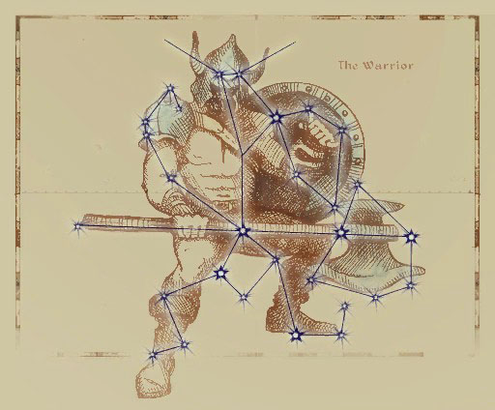

*The Warrior is the first Guardian Constellation and he protects his charges during their Seasons. The Warrior's own season is Last Seed when his Strength is needed for the harvest. His Charges are the Lady, the Steed, and the Lord. Those born under the sign of the Warrior are skilled with weapons of all kinds, but prone to short tempers.*

* *Trait*: **Iron Hand**

You inflict +1 damage on all physical attacks.

* *Star-Cursed Trait*: **Warwyrd**

You inflict +3 damage on all physical attacks instead on a +1, but you take a -1 to your Attunement.

***The Lady***

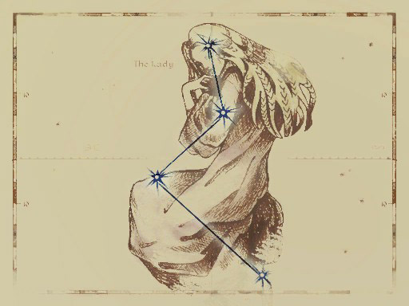

*The Lady is one of the Warrior's Charges and her Season is Hearthfire. Those born under the sign of the Lady are kind and tolerant.*

* *Trait*: **Lady’s Favor**

You gain a +5 to your Max Health.

* *Star-Cursed Trait*: **Lady’s Grace**

You gain an additional +5 to your Max Health but you take a -2 to your Stamina.

***The Lord***

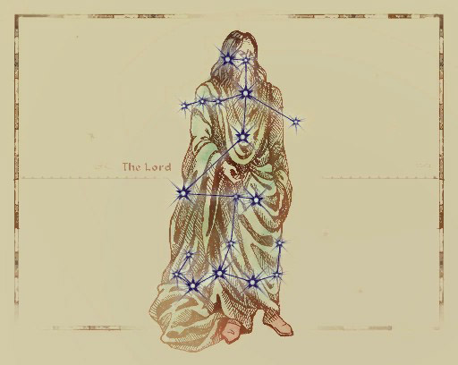

*The Lord's Season is First Seed and he oversees all of Tamriel during the planting. Those born under the sign of the Lord are stronger and healthier than those born under other signs.*

* *Trait*: **Blood of the North**

You naturally restore 4 Health over short rests.

* *Star-Cursed Trait*: **Trollkin**

Whenever you naturally regain Health, you double the restored amount but gain Weakness (Fire, 4).

* ***The Steed***

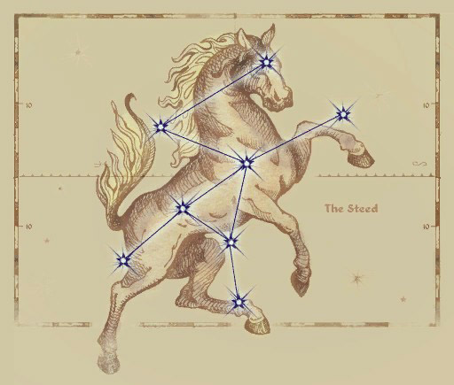

*The Steed is one of the Warrior's Charges, and her Season is Mid Year. Those born under the sign of the Steed are impatient and always hurrying from one place to another.*

* *Trait*: **Charioteer**

You gain +3 to your Move Speed.

* *Star-Cursed Trait*: **Beast of Burden**

You gain +4 to your Carry Rating but reduce your max Stamina by 2.

***The Thief***

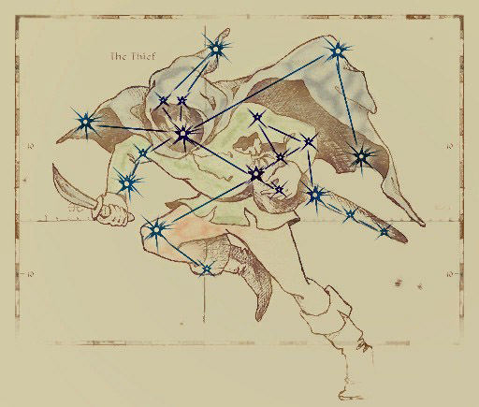

*The Thief is the last Guardian Constellation, and her Season is the darkest month of Evening Star. Her Charges are the Lover, the Shadow, and the Tower. Those born under the sign of the Thief are not typically thieves, though they take risks more often and only rarely come to harm. They will run out of luck eventually, however, and rarely live as long as those born under other signs.*

* *Trait*: **Danger Sense**

You gain +3 to your Initiative.

* *Star-Cursed Trait*: **Ill-Fortune**

Your Luck is set to 60 by default and has its max at 60 instead of 50, but you gain 2 Unlucky Numbers that will stay with you forever.

***The Lover***

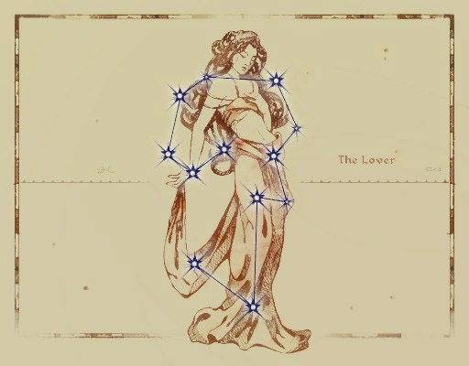

*The Lover is one of the Thief's Charges and her season is Sun's Dawn. Those born under the sign of the Lover are graceful and passionate.*

* *Trait*: **Mooncalf**

You gain +2 Max Stamina

* *Star-Cursed Trait*: **Lover’s Kiss**

You gain a +10 to all Speechcraft tests. However your Max HP is reduced by 5.

***The Tower***

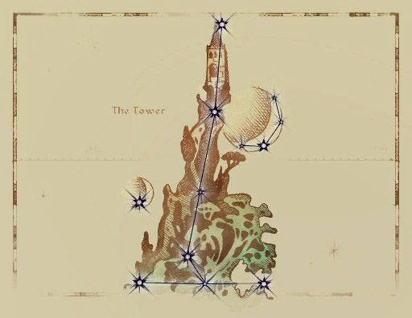

*The Tower is one of the Thief's Charges and its Season is Frostfall. Those born under the sign of the Tower have a lucky streak.*

* *Trait*: **Beggar’s Nose**

You gain +1 Lucky Number.

* *Star-Cursed Trait*: **Tower Key**

You have an additional +1 Lucky Number, but you lose 2 Additional Luck whenever you burn luck.

***The Shadow***

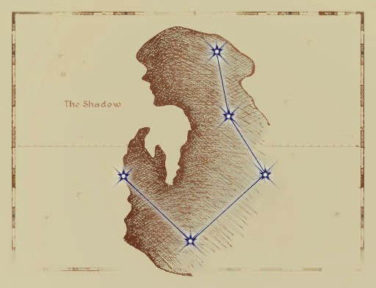

*The Shadow's Season is Second Seed. The Shadow grants those born under her sign the ability to hide in shadows.*

* *Trait*: **Shroud**

You gain a +10 to all Stealth Tests.

* *Star-Cursed Trait*: **Moonshadow**

Once per short rest, you can reroll a failed Sneak skill test. However, your max Speed is reduced by 2.

***The Mage***

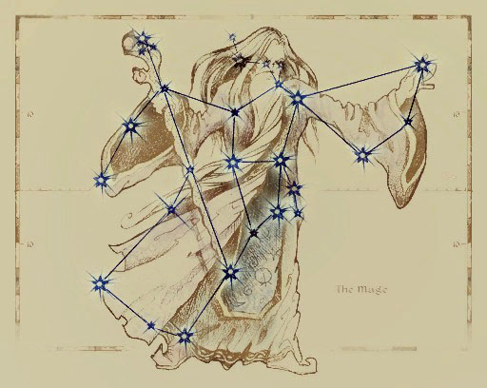

*The Mage is a Guardian Constellation whose Season is Rain's Hand when magicka was first used by men. His Charges are the Apprentice, the Golem, and the Ritual. Those born under the Mage have more magicka and talent for all kinds of spellcasting, but are often arrogant and absent-minded.*

* *Trait*: **Fay**

Gain Power Well (10)

* *Star-Cursed Trait*: **Arcanum**

You restore 2d10 extra Magicka on Short rests, but cannot regain Stamina over short rests.

***The Apprentice***

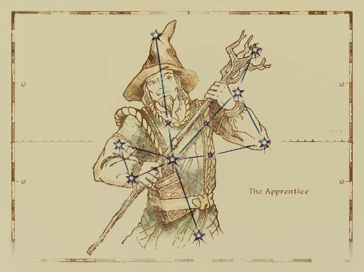

*The Apprentice's Season is Sun's Height. Those born under the sign of the apprentice have a special affinity for magic of all kinds, but are more vulnerable to magic as well.*

* *Trait*: **Elfborn**

Gain Power Well (20) and Weakness (Magic, 2)

* *Star-Cursed Trait*: **Void Seed**

Increases the Weakness to magic by 2, but you now inflict +3 damage with all of your damaging spells.

***The Atronach***

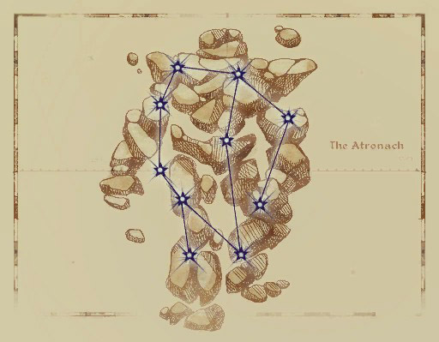

*The Atronach (often called the Golem) is one of the Mage's Charges. Its season is Sun's Dusk. Those born under this sign are natural sorcerers with deep reserves of magicka, but they cannot generate magicka of their own.*

* *Trait*: **Stunted Magicka**

You gain Power Well (30) but you only regain half your Magicka on long rests and none on short rests.

* *Star-Cursed Trait*: **Wombburn**

You gain Power Well (50) instead and cannot naturally regain magicka. However, every time you are affected by a spell cast by someone else, you regain Magicka equal to your Willpower Bonus + Any damage you take from the spell.

***The Ritual***

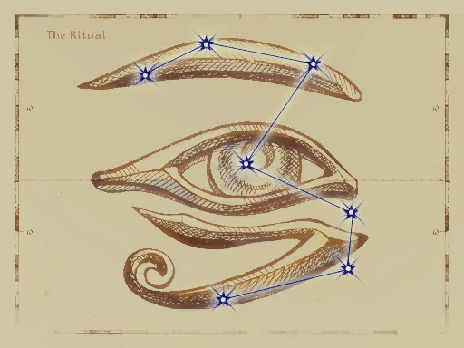

*The Ritual is one of the Mage's Charges and its Season is Morning Star. Those born under this sign have a variety of abilities depending on the aspects of the moons and the Divines.*

* *Trait*: **Mother’s Gift**

You gain +1 to your max Attunement.

* *Star-Cursed Trait*: **Blessed Touch**

Whenever you restore Health to yourself or another through a spell or through Medical treatment, you restore an additional 5 HP. However, you take a -5 to your max Health

***Cultures***

A character’s Culture represents the land and customs that shaped them throughout their life. The land of Tamriel is home to countless cultures and subcultures, but for the simplicity of the game, all cultures are provided with three variant ***Cultural Traits*** that represent the different characteristics of that culture’s variants.

When selecting your character’s Culture, you are given a list of ***Cultural Skills*** and are given an amount of ***Cultural Points*** by the Campaign’s starting power to distribute across the list of cultural skills as you see fit. Additionally, all Cultures have three ***Cultural Traits*** that offer the character a small boon. When selecting your culture, you may select one of these traits. You cannot put more than half your total cultural skill points into a single skill.

Additional Cultures will be introduced in the ***Advanced Player’s Guide***.

***Altmeri***

*“Fluff”*

***Cultural Language***

Altmeri

***Cultural Skills***

* *Alteration*
* *Restoration*
* *Conjuration*
* *Mysticism*
* *Illusion*
* *Destruction*
* *Lore*
* *Artistry*

***Cultural Traits (Choose One)***

* *Arcane Supremacy*

The Elves of the Summerset Isles are known to produce the most gifted of mages.

***Increase your WpB by +1 for Spell Overload***

* *Phynaster’s Lesson*

The ancestor god Phynaster taught the Altmer to live longer by shortening their stride.

***Your Speed is reduced by 1, you gain +4 HP.***

* *Shimmering Threads*

?

**?**

***Argonia***

*“Fluff”*

***Cultural Language***

Jel

***Cultural Skills***

* *Survival*
* *Sneak*
* *Evasion*
* *Athletics*
* *Marksman*
* *Alchemy*
* *Light Weapons*
* *Mysticism*

***Cultural Traits (Choose One)***

* *?*

?

**?**

* *?*

?

**?**

* *?*

?

**?**

***Bosmeri***

*“Fluff”*

***Cultural Language***

Bosmeri

***Cultural Skills***

* *Marksman*
* *Light Weapons*
* *Unarmed*
* *Sneak*
* *Awareness*
* *Survival*
* *Animal Handling*
* *Acrobatics*

***Cultural Traits (Choose One)***

* *Pact Adherent*

The pact demands that no source of meat is to be wasted. No source at all.

***This functions as a Bond. You must consume a piece of every “Meat” source that you kill, that it would be possible for you to retrieve, within 24 hours of the kill. Doing so during a rest period restores +2 SP and 5 HP.***

* *Way of the Hunt*

The life of the Bosmer is one where one must be willing to take a life to survive.

***You inflict +2 Damage vs. Beast type foes.***

* *Among the Green*

Moving through the forest canopy to avoid the various predators of the wild has taught you the benefits of moving quickly and silently.

***You cannot be tracked while moving alone through woodland environments. You may also conceal the passage of a Group of less than 10 people while traveling at a slow pace.***

***Bretonic***

*“Fluff”*

***Cultural Language***

Old Bretic

***Cultural Skills***

* *Riding*
* *Lore*
* *Heavy Weapons*
* *Block*
* *Speechcraft*
* *Conjuration*
* *Restoration*
* *Alteration*

***Cultural Traits (Choose One)***

* *Chivalry*

The heirs of the Direnni hold a strong belief in valor, honor, and justice.

***When you uphold a Bond, you regain 2 Luck instead of 1***

* *Daily Magic*

The people of High Rock, both high and low, tend to use magic to perform several daily tasks.

***Increase your WpB by +1 for Spell Restraint***

* *A New Hill*

“Find a hill, become a king.” An old Breton proverb used to describe the Bretons' drive for a better life.

***You gain +1 xp for “Successfully Resolving a Social Encounter” or “Completing a Major Campaign Objective” once per session***

***Colovian***

*“Fluff”*

***Cultural Language***

Tamrielic

***Cultural Skills***

* *Heavy Weapons*
* *Block*
* *Speechcraft*
* *Awareness*
* *Riding*
* *Athletics*
* *Restoration*

***Cultural Traits (Choose One)***

* *Highlander*

Living in the high altitudes and mountainous terrains of Colovia have toughened you to arduous paths and marches.

***You gain +1 Max Stamina***

* *Legion Pride*

The people of Colovia are the heart and soul of the Red Legion. Their sense of unity leaves them willing to fight and die together, rather than falling apart.

***You gain +1 DoS on Combat tests made while within 3m of an ally.***

* *?*

?

**?**

***Crown***

*“Fluff”*

***Cultural Language***

Yoku

***Cultural Skills***

* *Speechcraft*
* *Mercantile*
* *Lore*
* *Riding*
* *Alteration*
* *Light Weapons*

***Cultural Traits (Choose One)***

* *?*

?

**?**

* *?*

?

**?**

* *?*

?

**?**

***Dunmeri***

*“Fluff”*

***Cultural Language***

Dunmeri

***Cultural Skills***

* *Destruction*
* *Light Weapons*
* *Evasion*
* *Mysticism*
* *Alteration*
* *Illusion*
* *Marksman*
* *Awareness*
* *Lore*

***Cultural Traits (Choose One)***

* *Thrice-Blessed*

Living under the teachings of the three in your daily life has distilled their virtues within you.

**You gain a +2 to three different Attributes of your choice**

* *???*

?

***?***

* *???*

?

***?***

***Forebear***

*“Fluff”*

***Cultural Language***

Yoku

***Cultural Skills***

* *Light Weapons*
* *Heavy Weapons*
* *Block*
* *Athletics*
* *Riding*
* *Medicine*
* *Awareness*

***Cultural Traits (Choose One)***

* *The Ra’Gada Spirit*

?

**?**

* *Desert-Dweller*

?

***Gain Resist Fire (1) and you only suffer half the penalty from the Heat-Stroke condition.***

* *?*

?

**?**

***Khajiiti***

*“Fluff”*

***Cultural Language***

Ta’agra

***Cultural Skills***

* *Mercantile*
* *Sneak*
* *Security*
* *Awareness*
* *Acrobatics*
* *Unarmed*
* *Provisioning*

***Cultural Traits (Choose One)***

* *On Warm Sands*

?

***Gain Resist Fire (1) and you only suffer half the penalty from the Heat-Stroke condition.***

* *Sweet Tooth*

?

**?**

* *Moonpaths*

?

**?**

***Nibenese***

*“Fluff”*

***Cultural Language***

Tamrielic

***Cultural Skills***

* *Speechcraft*
* *Mercantile*
* *Illusion*
* *Riding*
* *Medicine*
* *Lore*
* *Destruction*
* *Alteration*

***Cultural Traits (Choose One)***

* *Cosmopolitan*

The people of the Niben frequently trade with many diverse groups, it makes it easier if you can talk.

***You begin play with Fluency (3) in one of the Common Tongues of your choice. Additionally, if you are speaking to someone in their “Native Tongue” you can reroll one failed Speechcraft or Mercantile skill test made against them. You can only reroll against the same target once per session***

* *Magocracy*

The highest regarded members of the Aristocracy of Nibenay are the Battlemages. This has led many of the Nibenese to idolize Mages and the practice of spellcraft itself.

**When you make a test to Learn a new spell, you gain a+2 to its DoS.**

* *?*

?

**?**

***Nordic***

*“Fluff”*

***Cultural Language***

Nordic

***Cultural Skills***

* *Light Weapons*
* *Heavy Weapons*
* *Block*
* *Unarmed*
* *Marksman*
* *Survival*
* *Athletics*
* *Provisioning*

***Cultural Traits (Choose One)***

* *Northerner*

The harsh cold of your northern home has left you inured to the biting winds.

***Gain Resist Frost (1) and you only take half the normal penalty from the Frostbite condition.***

* *Reveler (This will be redone when Provisioning is done)*

The peoples of the north are no stranger to celebration.

***Partaking in revelous activity during a rest period restores 2 HP or +1 SP***

* *Warborn*

One could count the years Skyrim has spent in peace using their fingers, and maybe those of their foes.

***You inflict +1 to all Physical Damage attacks***

***Orcish***

*“Fluff”*

***Cultural Language***

Orcish

***Cultural Skills***

* *Heavy Weapons*
* *Unarmed*
* *Block*
* *Survival*
* *Athletics*
* *Smithing*

***Cultural Traits (Choose One)***

* *War-Child*

You were raised by the War-Wife of your stronghold’s Chieftain. From a young age, she expected strength and would settle for nothing less.

***You gain +2 Max Health***

* *Hearth-Child*

Being raised by the Hearth-Wife had you working all day, running water, repairing structures, cooking, and aiding your kin in the mines.

***You reduce your speed penalty from being encumbered by 1 and test penalties by 10.***

* *Forge-Child*

Working alongside your stronghold’s Forge-Wife, you learned the craft of Malacath’s children.

***You start play with the “Orcish Design” smithing talent. You may also have 1 piece of starting equipment, be of Orcish Design***

***Velothi***

*“Fluff”*

***Cultural Language***

Dunmeri

***Cultural Skills***

* *Destruction*
* *Survival*
* *Marksman*
* *Awareness*
* *Athletics*
* *Acrobatics*
* *Sneak*

***Cultural Traits (Choose One)***

* *Nomad*

The nomadic tribes of old Resdayn are accustomed to life on the move.

***You can maintain full rest benefits while traveling at any pace.***

* *Reclaimer*

The Velothi are a highly religious people that hold their beliefs as the truest faith among the Dunmer. This zealous determination can push them beyond their limits.

***You gain +1 Max Stamina***

* *Ashlander*

Many of the Velothi tribes reside in the scotched lands across Morrowind known as the “Ashlands.”

***Gain Resist Fire (1) and you only suffer half the penalty from the Heat-Stroke condition.***

***Customizing with CrP***

You are given an allowance of Creation Points (CrP) based on the starting level of the Campaign. You may spend them on the options shown on the charts below and may spend them on Character Traits, or gain some extra CrP by taking some negative Character Traits. Any unspent CrP becomes XP after character creation.

***CrP Costs***

| ***Advancement*** | ***CrP Cost*** |
| --- | --- |
| Skill Point | (Skill Rank) |
| 1st Level Talent | 5 |
| 2nd Level Talent | 10 |
| 3rd Level Talent | 15 |
| Increase Attribute by 1 | 3*Bonus |
| Learning an Extra Spell ! | 5 |
| Learn a Ritual | 10 |

! = You get 1 Free Spell for every Rank beyond Novice in a Spell School you have.

***Skill Ranks and Costs***

| ***Skill Rank*** | ***Point Range*** | ***CrP Cost*** |
| --- | --- | --- |
| (1) Novice | 0 - 9 | 1 |
| (2) Apprentice | 10 - 19 | 2 |
| (3) Journeyman | 20 - 29 | 3 |
| (4) Adept | 30 - 39 | 4 |
| (5) Expert | 40 - 49 | 5 |
| (6) Master | 50 | 6 |

**Traits**

During character creation, players may take certain traits to add flavor to their characters. A character is not required to take any traits, but they’re recommended. Traits are chosen from a preset list, and each trait has an associated CrP cost or bonus: traits with positive effects (Listed here as Positive Traits) incur CrP costs, while traits with negative effects (Listed here as Negative Traits) provide CrP bonuses.

You can only gain a certain amount of bonus CrP based on your ***Campaign Starting Power***. Taking negative traits does not allow you to take more than your max bonus from the starting power.

***Positive Traits***

These traits offer a net positive to the character and cost a listed amount of CrP.

*Attractive*

***CrP Cost***: 3

The character is attractive and gains a +10 bonus to

any Personality test where their beauty plays a major

role in the outcome.

*Brave*

***CrP Cost***: 5

The character is lionhearted and does not scare easily. They gain a +20 bonus on Willpower tests to resist Fear or Intimidation.

*Danger-Sense*

***CrP Cost***: 4

The character has a sixth sense for danger. Any time the character is Surprised, they can choose to roll Initiative instead, but takes a -20 on all non-defensive reactions in the first Round of combat.

*Directional Sense*

***CrP Cost***: 2

The character has a good sense of direction, and can always find north when outdoors.

*First Impression*

***CrP Cost***: 3

The character makes a good impression, and gains a +10 bonus on any Personality test when first meeting someone new.

*Good with Animals*

***CrP Cost***: 3

The character has an affinity for animals and gains a +10 bonus on any Animal Handling test made to train or calm an animal.

*Pain Tolerant*

***CrP Cost***: 4

The character has a high threshold for pain, and gains a +2 to their Wound Threshold.

*Situational Awareness*

***CrP Cost***: 3

The character is hyper-aware of their surroundings, and can ignore any negative modifiers to Perception for being distracted, but not for poor lighting or environmental conditions.

*Strong Immune System*

***CrP Cost***: 5

The character has a strong immunity to common diseases and gains a +10 to Endurance tests made to resist or overcome a common disease.

*Acute Hearing*

***CrP Cost***: 4

The character has such an acute sense of hearing that they do not suffer any penalties due to distracting sounds to their Awareness.

*Rapid Recovery*

***CrP Cost***: 5

The character is capable of recovering from wounds faster than their peers. The character doubles all HP they recover naturally. When stacked with the Star-Cursed Lord Birthsign, you triple your natural healing, not quadruple.

*Multilingual*

***CrP Cost***: 3

The character is given +2 points to spend on their starting languages.

***Negative***

These traits offer a net penalty to the character and grant a bonus to their Starting CrP.

*Addiction to (X)*

***CrP Bonus***: +3

The character is addicted to some substance, such as alcohol, moonsugar, skooma, or even more alien or outlandish drugs such as feldew. Should the character not be able to indulge in the drug regularly (more accessible drugs require more frequent access), they suffer a -10 penalty on all tests, which increases in severity by an additional -10 to a maximum of -30 for each passing day until they get their fix.

*Aversion to (X)*

***CrP Bonus***: +2

The character is afraid of or averse to something (X). This can be used to represent a phobia, compulsive avoidance, or strong dislike of a certain thing. When exposed to their aversion, the character suffers a -10 on all tests.

*Combat Paralysis*

***CrP Bonus***: +2

The character has a habit of freezing in dangerous

situations. When rolling for Initiative, the character rolls twice and takes the lowest.

*Disturbing Voice*

***CrP Bonus***: +2

The character has an intimidating, disturbing voice. They gain a +10 bonus to Speechcraft tests made to intimidate, but suffer a -20 to all other Personality based tests that involve speaking.

*Illiterate*

***CrP Bonus***: +1

The character was never taught to read or write. They cannot read or write, obviously.

*Low Pain Tolerance*

***CrP Bonus***: +3

The character has a low threshold for pain, suffering a -3 to their Wound Threshold

*Oblivious*

***CrP Bonus***: +3

The character is often oblivious to danger. The

character suffers a -20 on Perception based tests that

would determine if the character is surprised by an

enemy or not. The character also takes a -1 penalty to their Passive Awareness.

*Timid*

***CrP Bonus***: +3

The character is timid and scares easily. They suffer a -10 penalty on Willpower based tests to resist fear or intimidation

*Ugly*

***CrP Bonus***: +2

The character is ugly and suffers a -10 penalty to any Personality based tests where their appearance plays a major role in the outcome.

*Weak Immune System*

***CrP Bonus***: +3

The character has a poor immunity to common diseases and takes a -10 penalty to Endurance tests made to resist or overcome a common disease.

*Lingering Injury*

***CrP Bonus***: +4

The character has an old injury that comes back to bug them at the worst times. The GM and the player should work out the specifics of the injury, and how it affects the character.

*Stunted Magicka*

***CrP Bonus***: +4

The character was born with a peculiar block to their connection to Aetherius, resulting in a -1 penalty to their max Attunement and they cannot naturally recover their Magicka.

***Special Traits***

All special traits must be permitted specifically by the Gamemaster. These traits may grant both positive and negative effects and should provide Roleplay features for both the Player and the GM.

*Noble Birth*

***CrP Cost***: 8

You are a child of noble birth and with that comes the privileges and burdens of such a station. Discuss the exact privileges and assets granted to you by your station and what responsibilities you may have with your GM.

A constant privilege is that you tend to be treated better by other nobles and many of the common folk would show their respect out of loyalty or caution, wanting to avoid the ire of the nobility. You also have access to a sizable family vault for financial aid, ***doubling whatever starting Gold*** you begin play with. On the other hand, your actions reflect upon your noble house and family. Failing to protect your honor and the honor of your kin may result in negative actions taken against you. Additionally, many nobles have their fair share of enemies and rivals that may cause issues for you.

*Dhampyr*

***CrP Cost***: 12

On rare occasions, a living woman who joins in union with a male vampire may become with child, bearing a Half-Vampire. The children of these unions are referred to as a Dhampyr and inherit some traits from their Vampiric blood. Many people view vampires and everything relating to them as evil and an abomination and this opinion tends to carry on to Dhampyrs. However, they are very rare and few people would even believe it is even possible for one to exist. The House of Dibella holds the belief that intimate union, and the fruits thereof, with an Undead is seen as anathema to their Goddess.

Dhampyrs are very physically gifted, they are stronger and faster then their kin and they are albino, with reddish eyes and pale skin and hair.

Dhampyrs gain the following traits.

* ***Weakness (Fire) ‘2***
* ***Sun-Scarred***
* ***Resist Normal Weapons***
* ***+1 Speed***
* ***+1 Stamina***

A Dhampyr can have their Vampiric blood awake within them, turning them into full vampires. This must be done by the Player’s choice and costs them ***50xp***. Once this experience is spent, the character becomes lethargic over a three day period. After which they will awake as a Vampire of the Bloodline their vampire sire was a part of. When a Dhampyr becomes a Vampire, they lose all of their Dhampyr traits, aside from their appearance, and replace them with those of their Vampiric Bloodline.

***Bonds***

Bonds 0are short phrases that describe something unique about your character personality. They are not necessarily something that makes you a “bad person”, but something that can complicate your character’s life. Whether its a vendetta, a personality compulsion, a large debt, an inconvenient loyalty, or a forbidden love, Bonds should be thematic and resonate with your character to bring depth and more importantly, interesting and organic plot hooks.

***Example Bonds***

* Insatiable greed.
* A poor temper.
* A forbidden lover.
* A vow of pacifism.
* Large debts to an illegal organization.
* Being a wanted criminal.
* Holding a grudge.
* Insurmountable pride.

***Gaining Bonds***

During character creation, characters are encouraged to take a Bond or two. During the course of the game, the GM may prompt you to clear existing Bonds if they are resolved, or add new Bonds that arise throughout the course of the campaign.

***Exploiting Bonds***

If your character is in a situation where your Bonds

will inconvenience, harm, or otherwise make

a situation worse, someone, including you, can Exploit your Bond by describing how its relevant and offering a complication. In that case, you get two options:

* Accept the complication and gain +1 Luck.
* Burn 1 Luck to avoid the complication.

***Character Progression***

The primary means by which characters progress in the UESRPG is through the accumulation and use of Experience Points (also known as XP) awarded by the GM. XP can be spent by characters to purchase attribute advances, train new skills, increase skill ranks, learn new magic, and purchase talents.

Listed below are some rule variants that detail when and where Players can spend their Experience. GM’s are meant to select one, or multiple, of these rules to use for their campaign.

***Safe Haven***

This rule has players only allowed to spend their Experience while they are in a City or a Base of an ally or their own.

***Rest & Meditation***

This rule requires the players to take an Extended Rest (One Week) in order to spend their Experience.

***In Between Sessions***

This rule allows players to spend their Experience in between sessions. Their points are only dedicated at the start of the next session, so if they want to test out their advancements with someone before the next session, they can.

***Campaign Progression Level***

At the start of your Campaign, the GM must decide on a “Progression Rate” which will determine the amount of Experience the players will gain each session. This rate takes the form of a multiplier to the Exp Rewards listed below.

* ***Natural = As Listed***
* ***Heroic = x2 Exp***
* ***Legendary = x5 Exp***

***Experience Rewards***

*Action = Xp Reward (no stacking)*

Attended the Session = 2 xp

Completed a Major Campaign Objective = 3 xp

Successfully Resolved a Social Encounter = 2 xp

Dealt with a Lock or Trap = 1 xp

Engaged in Roleplay = 1 xp

Crafted an item = 1 xp

Successfully Solved a Puzzle = 1 xp

Traveled to a New Landmark = 2 xp

Defeated a Challenging Foe = 2 xp

***Skill Ranks***

| ***Skill Rank*** | ***Point Range*** |
| --- | --- |
| (1) Novice | 0 - 9 |
| (2) Apprentice | 10 - 19 |
| (3) Journeyman | 20 - 29 |
| (4) Adept | 30 - 39 |
| (5) Expert | 40 - 49 |
| (6) Master | 50 |

***Progression Costs*** *(Flesh Out)*

*Article = Xp Cost*

[0-49] Skill Point = (1+Rank)*2

* Master Rank (50) costs 20xp

Talents = Level*10

* Levels (1-3)

Attributes Point = 5*Bonus